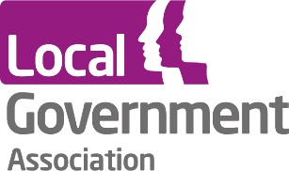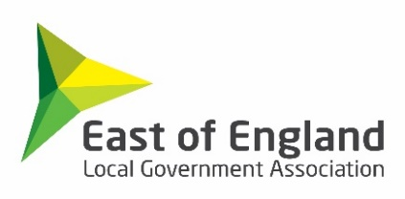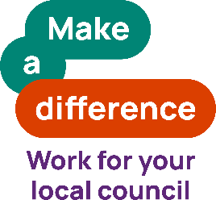

**National Recruitment Campaign for Local Government**

**5 September 2024, 09:30 – 13:50**

**Rowley Mile, Newmarket Racecourse**

**AGENDA**

|  |  |
| --- | --- |
| **Time** | **Session** |
| **09:30** | **Registration, refreshments, and an opportunity to visit sponsor table** |
| **10:00** | **Welcome and introductions**  Alison Thompson, Head of Employer Services, East of England LGA (EELGA) |
| **10:05** | **Introduction to the ‘Make a Difference, Work for Your Local Council’ campaign**  D’jaleh McCrystal and Will Oldham, LGA |
| **10:20** | **Creative development of national recruitment campaign:** **toolkit for councils, presentation,** **Q&A and group activity**  Storycatchers |
| **11:00** | **Media strategy for the national campaign roll-out: presentation, Q&A, and group activity**  Republic of Media |
| **11:50** | **Next steps, principles of the national campaign and further questions and comments**  Will Oldham, LGA |
| **12:10** | **Lunch, opportunity for networking and view sponsor table** |
| **13:10** | **Opus People Solutions**  Brad Sinclair |
| **13:45** | **Summary and next steps**  Alison Thompson, Head of Employer Services, East of England LGA (EELGA) |
| **13:50** | **Conference close** |

**Sponsored by:**

